**SUSTAINABLE GROWTH AND FUTURE PERSPECTIVES OF AGRICULTURE**

**ABSTRACT**

India, a land of diverse agro-climatic zones, is a major producer of various food crops. Staple crops like rice, wheat, and millets, along with pulses, oilseeds, and sugarcane, form the backbone of its agricultural economy. However, the future of food crop production in India is intertwined with a complex interplay of factors, including climate change, increasing population, water scarcity, and evolving consumer preferences.

The agricultural industry is getting more data-centric and requires precise, more advanced data and technologies than before, despite being familiar with agricultural processes. The agriculture industry is being advanced by various information and advanced communication technologies, such as the Internet of Things (IoT). The rapid emergence of these advanced technologies has restructured almost all other industries, as well as advanced agriculture, which has shifted the industry from a statistical approach to a quantitative one. This radical change has shaken existing farming techniques and produced the latest prospects in a series of challenges. This enlightens the potential in the advancement of agriculture and the challenges faced when combining these advanced technologies with conventional agricultural systems. Numerous sensors that can be implemented for specific agricultural practices require best management practices.

By addressing these challenges and adopting innovative solutions, India can strive to maintain its food security, enhance farmers' livelihoods, and contribute to global food production.

**INTRODUCTION:**

The aim of this research is to investigate the concept of sustainable growth in agriculture, exploring its current status, challenges, and future perspectives. This study seeks to analyze the key factors that contribute to sustainable agricultural practices, assess their potential to support long-term food security, and examine how these practices can be scaled to meet the growing demands of a changing global population. Additionally, the research will explore emerging technologies, policy frameworks, and socio-economic factors that influence the future trajectory of sustainable agriculture, with a focus on balancing environmental conservation, economic viability, and social equity. By evaluating both the opportunities and obstacles in achieving sustainable agricultural growth, this research aims to provide insights into strategies that can promote resilience, innovation, and sustainability in the agricultural sector.

How can technological advancements and innovative agricultural practices be integrated to achieve sustainable agricultural growth?

The purpose of this research is to explore the potential of technological innovations and sustainable agricultural practices to ensure a secure and sustainable food future.  Identifying and analyzing emerging technologies like precision agriculture, drones, AI, that can enhance agricultural productivity and resource efficiency.  Forecasting future trends in agriculture and identifying critical challenges and opportunities that will shape the sector in the coming decades.

The primary objective of this research is to delve into the intersection of technological advancements and sustainable agricultural practices to ensure a secure and sustainable food future. By examining emerging technologies like precision agriculture, AI, It aims to assess their potential to enhance agricultural productivity and resource efficiency. This seek to identify effective strategies for supporting the adoption of sustainable agricultural practices and technologies. Ultimately, this research aims to forecast future trends in agriculture and propose innovative solutions to address the challenges and opportunities that lie ahead.

**LITERATURE REVIEW**

According to [Sustainable Agriculture Research & Education Program](https://sarep.ucdavis.edu/)a program of UC Agriculture & Natural Resources **Sustainable agriculture** is defined as Sustainable agriculture is a farming practice that aims to meet the needs of the present and future generations.

In the review named Agricultural Technologies in India by P K Joshi and Deepak Varshney found that Adoption of improved technologies have shown an unambiguous positive impact on agricultural productivity and agricultural production. More specifically, these have had an impact on increasing farmers’ income, income diversification, conserving natural resources, improving input use efficiencies, generating employment opportunities and promoting diversification.

The Journal of Agricultural Engineering (India) is a peer-reviewed Journal and publishes interdisciplinary basic and applied research manuscripts of engineering and technology to address the problems of agricultural, food, and biological systems. The journal publishes papers of both theoretical and applied nature, with a special focus on experimental research, new design criteria, mathematical modelling and innovative approaches relating to all fields of agricultural Engineering and technology.

**METHODOLOGY**

A conceptual framework illustrating the interconnections between sustainable agricultural practices, technological innovation. Primary data collected directly through surveys, interviews, and field observations. Secondary data Obtained from existing sources like government reports, academic publications, and international databases. Statistical techniques like descriptive statistics, correlation analysis, and regression analysis will be used to analyze the quantitative data. A visual representation charts are used. The adoption of technology in agriculture offers significant potential for increased productivity, efficiency, and sustainability. Use of technology to optimize agricultural practices, including site-specific nutrient application, variable-rate irrigation, and precision planting. However, it also comes with substantial costs, both initial and ongoing. The costs associated with agricultural technology can vary widely depending on the specific technology, its scale of implementation, and the complexity of the system. Regular maintenance and repair of equipment, Costs associated with storing and processing large amounts of data, Ongoing costs for internet connectivity and data transfer. Funds are required to address these costs. Low-interest loans to farmers for technology adoption etc,. There are challenges and considerations to be taken. Ensuring equitable access to technology, especially in rural areas. Training farmers and agricultural workers to use new technologies effectively. Protecting sensitive data and ensuring data privacy. Careful evaluation of the long-term benefits of technology investments.

**ALGORITHM**

Needs Assessment: Assess the specific needs of the farming community, such as water scarcity, soil degradation, pest control, or market access. Determine the most pressing issues and their potential impact on agricultural sustainability.

Sustainable Practices Selection: Conservation Agriculture, Organic Farming, Precision Agriculture.

Resource Assessment and Management

Technology Adoption

Monitoring and Evaluation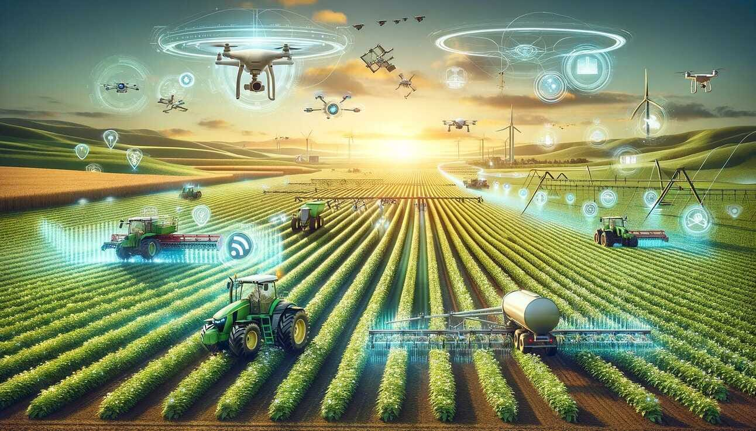

**PRELIMINARY DATA**

All the traditional approaches have been changed and overlapped by advanced technologies, such as the IoT . Currently, the implementation of various wireless sensors and IoT sensors leads to the gateway of many innovations for crop improvement. Several traditional crop issues, including disease management, effective irrigation, cultural practices, and drought responses, are currently addressed by these new emerging technologies.

Precision agriculture, a technological marvel, is revolutionizing the way farming is conducted. By harnessing the power of GPS technology, remote sensing, and data analytics, farmers can optimize resource use, minimize waste, and maximize crop yields. This data-driven approach enables precise application of inputs like fertilizers and pesticides, tailored to the specific needs of each field. Moreover, real-time monitoring of crop health and soil conditions empowers farmers to make timely decisions, leading to improved efficiency, reduced environmental impact, and enhanced profitability. As technology continues to advance, precision agriculture holds the key to sustainable and productive farming in the future. The effectiveness of precision agriculture is supported by a growing body of evidence. Numerous studies have demonstrated significant improvements in crop yields, reduced input costs, and enhanced environmental sustainability. For instance, research has shown that precision farming techniques can reduce fertilizer and pesticide usage by up to 20% without compromising crop quality. By optimizing resource allocation and minimizing waste, precision agriculture contributes to a more sustainable and resilient food system. Additionally, the ability to monitor crop health in real-time allows for early detection and treatment of pests and diseases, reducing the need for broad-spectrum chemical applications. As technology continues to advance, the potential of precision agriculture to transform the agricultural landscape is immense. Precision agriculture has yielded significant results in terms of increased efficiency, reduced environmental impact, and improved profitability.

By optimizing resource allocation and minimizing waste, farmers have experienced substantial benefits.Studies have shown that precision farming can lead to a 4% increase in crop production, a 7% reduction in fertilizer use, a 9% decrease in herbicide and pesticide applications, a 6% reduction in fossil fuel consumption, and a 4% decrease in water usage.Additionally, precision agriculture can improve soil health, reduce erosion, and enhance biodiversity.By adopting these technologies, farmers can contribute to a more sustainable and resilient food system.

**Key Categories of Precision Farming**

Precision agriculture encompasses a variety of technologies and techniques that work together to optimize farming practices. Some of the key categories include:

1. **GPS Technology:** Global Positioning Systems provide accurate location data, enabling farmers to map fields, guide equipment, and apply inputs with precision.
2. **Remote Sensing:** Utilizing satellite imagery and aerial drones to monitor crop health, soil moisture, and other factors. This technology helps identify areas of stress or disease, allowing for timely interventions.
3. **GIS (Geographic Information Systems):** Analyzing spatial data to create detailed maps of fields, enabling farmers to identify variations in soil fertility, topography, and other factors.
4. **Variable-Rate Technology (VRT):** Applying inputs such as fertilizers and pesticides at varying rates across a field, based on specific needs. This optimizes resource use and reduces environmental impact.
5. **Yield Mapping:** Using GPS technology to record crop yields across a field, enabling farmers to identify areas of high and low productivity. This information can be used to make informed decisions for future planting and management.
6. **Soil Sensors:** Monitoring soil moisture, temperature, and nutrient levels to optimize irrigation and fertilization practices.

By integrating these technologies, farmers can significantly improve their efficiency, reduce costs, and enhance the sustainability of their operations.

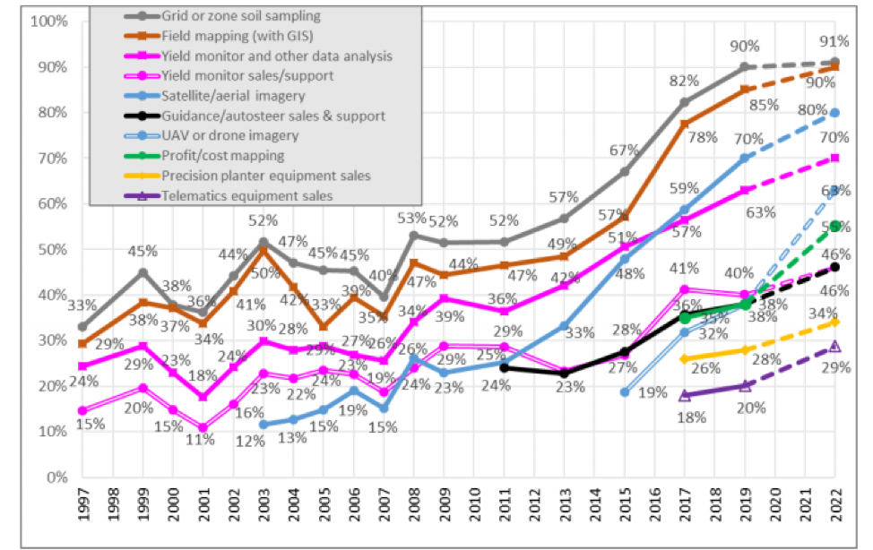

**Graph Inference**

The chart shows a general upward trend in the adoption of various precision agriculture technologies from 1997 to 2022. This suggests that the industry has been steadily embracing these technologies over time.

* **Grid or Zone Soil Sampling:** This technology has seen a consistent increase in adoption, reaching around 91% by 2022. This indicates a strong emphasis on understanding and managing soil variability for optimized crop management.
* **Field Mapping (with GIS):** This technology also shows a significant upward trend, with adoption reaching around 90% by 2022. This suggests that farmers are increasingly using GIS tools to analyze field data and make informed decisions.
* **Yield Monitor and Other Data Analysis:** This technology has experienced a steady increase in adoption, reaching around 90% by 2022. This indicates the importance of using yield data to monitor crop performance and make adjustments as needed.
* **Satellite/Aerial Imagery:** This technology has seen a notable increase in adoption, reaching around 82% by 2022. This suggests that farmers are leveraging remote sensing data to assess crop health and monitor field conditions.
* **Guidance/Autosteer Sales & Support:** This technology has experienced a significant increase in adoption, reaching around 78% by 2022. This indicates the growing use of automated steering systems to improve efficiency and reduce operator fatigue.
* **UAV or Drone Imagery:** This technology has seen a steady increase in adoption, reaching around 67% by 2022. This suggests that farmers are using drones for data collection and analysis, such as crop health assessments and field mapping.
* **Profit/Cost Mapping:** This technology has experienced a moderate increase in adoption, reaching around 59% by 2022. This suggests that farmers are using data to analyze profitability and identify areas for improvement.
* **Precision Planter Equipment Sales:** This technology has seen a moderate increase in adoption, reaching around 57% by 2022. This indicates the growing use of precision planting equipment to improve seed placement accuracy and spacing.
* **Telematics Equipment Sales:** This technology has experienced a moderate increase in adoption, reaching around 53% by 2022. This suggests that farmers are using telematics to monitor and manage their equipment remotely.

Overall, the chart suggests that precision agriculture technologies are becoming increasingly important in the agricultural industry. Farmers are using these technologies to improve efficiency, reduce costs, and increase profitability.

**DISCUSSION**

**Status of Precision Farming in India**

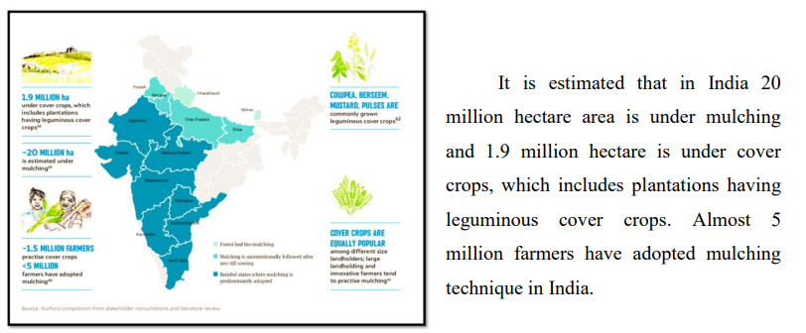

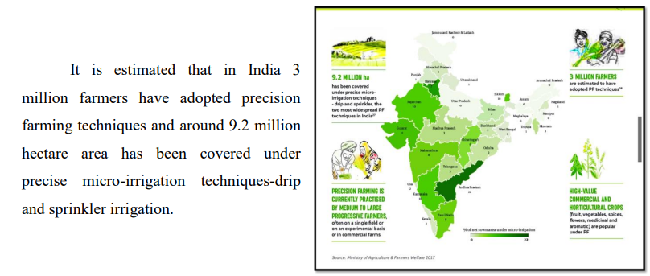

**FINDINGS**

**Increased Yield:**

* Precision agriculture, by optimizing resource allocation and minimizing waste, can lead to a substantial increase in crop yields. This is particularly beneficial in regions with limited arable land and increasing food demands.

**Reduced Input Costs:**

* By applying inputs like fertilizers and pesticides only where needed, precision agriculture significantly reduces input costs. This not only saves farmers money but also minimizes the environmental impact of excessive chemical use.

**Enhanced Environmental Sustainability:**

* Precision agriculture promotes sustainable farming practices by reducing soil erosion, water pollution, and greenhouse gas emissions. By minimizing the use of chemical inputs and optimizing resource use, it contributes to a healthier ecosystem.

**Economic Benefits:**

* The combination of increased yields, reduced costs, and improved efficiency leads to enhanced profitability for farmers. This can contribute to the overall economic growth of agricultural regions.

COMPARISON BETWEEN TRADITIONAL AND PRECISION FARMING

|  |  |
| --- | --- |
| In traditional farming, the reliance on manual labour is predominant. Tasks such as planting, harvesting, and monitoring are often performed by hand, requiring a significant workforce and intense labour hours of work. | Precision farming significantly reduces the demand for manual labor through the integration of automated machinery and robotics. This not only streamlines operations but also enhances overall efficiency by allowing farmers to focus on more strategic aspects of crop management. |
| Traditional farming relies on conventional and often manual methods, with minimal incorporation of advanced technologies. | Precision farming, however, embraces technology wholeheartedly. It integrates data sensors, GPS technology, and automated machinery to optimize various aspects of cultivation, providing farmers with real-time data and insights to make informed decisions. |
| In traditional farming, planting and irrigation are typically carried out uniformly across entire fields by hand and without considering variations in soil types or crop needs. | Precision farming, on the other hand, customizes planting and irrigation processes based on specific requirements. Data sensors and monitoring systems assess soil conditions, enabling farmers a precise control over planting depths and irrigation levels. |
| Traditional farming often relies on visual assessments and historical knowledge for crop monitoring. | Precision farming, however, employs drones, sensors, and other technologies to provide real-time data on crop health. |
| Traditional farming relies on observed knowledge and experience from the past generations They also limit the use of data for decision-making, since previously data was not available to farmers. | Precision farming, lives on data and analytics. Advanced technologies collect and analyses the real-time data, providing farmers with valuable insights for informed decision-making. |
| Traditional farming practices are often passed down through generations and may have a lower learning curve due to their reliance on empirical knowledge. | Precision farming, incorporating advanced technologies, may require a steeper learning curve for farmers to adapt to and master the use of data sensors, GPS technology, and other high-tech components. |

Precision agriculture is a game-changer in the field of agriculture. By harnessing technology to optimize farming practices, it offers numerous benefits.

**Precision Farming and the Future of Agriculture**

**Role of Artificial Intelligence and Machine Learning in Precision Agriculture**

Although IoT is still at a nascent stage, the governments of agriculture-dominant economies do invest in other cutting-edge technologies like artificial intelligence and machine learning (AI/ML) to make smarter agriculture decisions. In countries like India, the implementation of [IoT in agriculture](https://www.cropin.com/iot-in-agriculture) has its own set of unique benefits and challenges.

Firstly, the farmers fear upgrading to Agri tech as they lack knowledge about the applicability of the technology in agriculture. Besides this, the sensors, robots, and drones are expensive, have high maintenance costs, and require technically trained labour to operate. Further, the captured data needs to be analysed in a lab or using specialized instruments on the farm. Also, a variety of sensors are required for collecting data on different parameters, which need to be analysed separately, hence driving operational costs higher. Therefore, the digital farming solution must be cost-effective and highly scalable, considering the various sizes of farms.

**STATEMENT OF LIMITATION**

**LIMITATIONS AND WEAKNESSES**

Precision farming, despite its many advantages, faces several challenges that can limit its effectiveness and widespread adoption. One of the primary obstacles is the high initial investment required for advanced technologies like GPS systems, sensors, drones, and specialized software, which can be prohibitively expensive for small to medium-sized farms. Additionally, the complexity of these tools often presents a steep learning curve, requiring farmers to acquire new skills in both technology and data interpretation. The vast amount of data generated by precision farming technologies can overwhelm farmers, especially when the accuracy of sensors and the data collected is not always reliable, leading to potential misinterpretations and poor decision-making. Moreover, the dependency on technology makes farms vulnerable to system failures or connectivity issues, which can disrupt operations, especially in remote areas with limited infrastructure. There are also concerns around data privacy and security, as the collection of sensitive farm data raises the risk of cyberattacks or breaches. Precision farming's reliance on specialized expertise and high-tech equipment can further strain smaller operations, while larger farms may have the resources to capitalize on these innovations. Furthermore, precision farming may not be suitable for all types of farming systems, particularly those that rely on diverse crops or more traditional practices. Finally, there are environmental and social considerations, as the technology can exacerbate inequalities between large and small-scale farms, and if misapplied, it could lead to overuse of resources like water and fertilizer, negatively impacting soil health and biodiversity. Overall, while precision farming offers significant potential, overcoming these challenges requires careful management, substantial investment in training, and ongoing advancements in technology to make it more accessible and adaptable for all types of farmers.

Precision farming offers significant benefits in terms of improving efficiency, boosting crop yields, and enhancing sustainability. By using advanced technologies like GPS, sensors, and drones, it allows for more precise application of resources such as water, fertilizers, and pesticides, leading to reduced waste, lower costs, and higher productivity. Additionally, precision farming enables data-driven decision-making, allowing farmers to optimize planting, irrigation, and pest control, while also improving long-term planning through insights into soil health, weather patterns, and crop trends. This results in better resource management and reduced environmental impact, such as minimizing chemical runoff and conserving water. However, while it can improve many aspects of farming, precision farming is not a cure-all. It cannot eliminate all farming risks, such as extreme weather or unpredictable pest outbreaks, and it does not address the underlying economic inequalities that can limit access to the technology, particularly for small-scale or resource-poor farmers. Additionally, while precision farming provides valuable data, it cannot replace the expertise and intuition of experienced farmers who still need to interpret this information and apply it in context. Furthermore, the technology requires adequate infrastructure, such as reliable internet and electricity, which may not be available in all regions. Precision farming also cannot ensure profitability on its own, as farmers are still subject to market fluctuations and other external factors. Lastly, it is not a one-size-fits-all solution; the technology may not be suitable for all farming systems, particularly those that are low-tech, diverse, or organic. In essence, while precision farming can transform many aspects of modern agriculture, its success depends on thoughtful integration with existing farming practices, infrastructure, and the ability to adapt it to specific farm conditions.

**CONCLUSION**

Precision farming is becoming increasingly important as the global demand for food grows, environmental concerns rise, and agriculture faces the pressures of climate change. One of the key advantages of precision farming is its ability to significantly improve the efficiency of agricultural practices. By utilizing technologies like GPS, sensors, and drones, precision farming allows farmers to apply water, fertilizers, and pesticides with pinpoint accuracy, reducing waste and lowering input costs. This not only helps farmers increase their productivity but also minimizes the environmental footprint of farming, promoting more sustainable practices that conserve resources and reduce pollution. Another critical aspect of precision farming is its role in enhancing crop yields. By providing real-time data on soil health, crop conditions, and weather patterns, precision farming enables farmers to make more informed decisions. This leads to better crop management, including optimal planting, irrigation, and pest control, which can result in higher yields per acre. In regions where land and water resources are limited, this ability to maximize output from available resources is crucial for food security. Moreover, precision farming helps mitigate the impacts of climate change by enabling more adaptive and resilient farming practices. With real-time data, farmers can monitor changes in weather and adjust their operations accordingly, such as shifting planting schedules or varying irrigation rates. This adaptability is especially important in the face of unpredictable weather patterns and shifting growing seasons.

Beyond improving productivity and sustainability, precision farming also allows for better long-term planning. By tracking soil conditions, crop performance, and other environmental factors over time, farmers can make more accurate predictions about future crop needs and optimize their practices for long-term soil health and farm profitability.

Overall, precision farming is essential for modern agriculture, as it allows for a more efficient, sustainable, and data-driven approach to farming. As the world’s population continues to grow and environmental pressures mount, precision farming offers a way to produce more food with fewer resources while safeguarding the environment for future generations.

**REFERENCES AND BIBLIOGRAPHY**

MOKARIYA, L. K. AND MALAM, K. V., 2020, Precision agriculture – a new smart way of farming. Agricultural & Environment E- Newsletter. 1(2)

DAMA, V. R., SINGH, J. P., SHARMA, S., KHAR, S. AND SHRIVASTAVA, R. K., 2020, Scope and adoption of precision farming in India. Agricultural & Environment ENewsletter.1(3)

Pretty, J. Agricultural sustainability: Concepts, principles and evidence. Philos. Trans. R. Soc. Lond. Ser. B 2008, 363, 447–465. [CrossRef] [PubMed]

[Sustainable Agriculture Research & Education Program](https://sarep.ucdavis.edu/)a program of UC Agriculture & Natural Resources

Agricultural Technologies in India by P K Joshi and Deepak Varshney

Singh, M. Indian agriculture: An overview. Agric. Res. J. 2012

Mehta A, and Masdekar M. 2018. “Precision agriculture — a modern approach to smart farming”. Int J Sci Eng Res

Mokariya, L.K;, and K.V Malam. 2018. “Precision Agriculture — A New Smart Way of Farming.” Newsletter. <https://agrineny.com/wpcontent/uploads/2020/09/AEN_October2020.pdf>.

 Ravikumar R, and Gopu J.A . 2016. “An overview of the implementation of precision farming projects” MPRA Paper 73674, University Library of Munich, Germany.

C.R. Sukumar HYDERABAD, May 24, 2003 , Precision farming may turn a reality Financial Daily from THE HINDU group of publications. 3. Iida, M., Umeda, M., Kaho, T., Le

<https://www.ceew.in/publications/sustainable-agriculture-india/precision-farming>

The International Society of Precision Agriculture ([https://www.ispag.org/](https://urldefense.proofpoint.com/v2/url?u=https-3A__www.ispag.org_&d=DwMFAg&c=vh6FgFnduejNhPPD0fl_yRaSfZy8CWbWnIf4XJhSqx8&r=ZdOeLICp-TQzJn7IBjoVTgXQSQ4s-y_tJNSDmejdM7U&m=NIzYFzTTMdSkCE0SOmeH2GSE4hoUm9kQ7k-qV4SL6bw&s=u73H2yj-HpgNE5hE5nOtC3qV_5hY-JmsVabX-Yk1cZs&e=) ) adopted the definition of precision agriculture in 2019

Dev Prakash Shastry Marg on behalf of the National Academy of Agricultural Sciences